

AMERICAN INTERNATIONAL UNIVERSITY-BANGLADESH
Faculty of Science and Technology Department of Computer Science CSC 3215: Web Technologies
Semester: Summer 2025-26 Group No:11 Section: O

Group Members:

SL. | Student ID | Name | Role | Signature
12 | 23-50770-1 | Shaikh Zarif Shahriar | Group Leader | Zarif
05 | 23-50041-1 | Md Afrazur Rahman | Member | Afraz
 |  |  | Member
 |  |  | Member
Project Title
TurfGo - A turf booking system
Short Description
TurfGo is a web-based turf booking application. Users can search and book turf slots in the app. The service enables the players to check available slots, while it helps turf staff and admins manage day-to-day matches, avoid double bookings, and monitor all the record-keeping digitally.
Introduction
Renting sports turfs for football and cricket has become very popular nowadays, but many local turfs still take bookings over phone or direct messages. This mode of booking leads to various problems such as double booking, loss of customer data and miscommunication regarding the timing of matches. TurfGo is an application that provides a web-based interface where players can browse and book their preferred matches against time slots. Using PHP and MYSQL scripting languages ​​, the web application helps verify the booking of pitches to avoid overlaps while allowing turf owners to manage and monitor their daily bookings.
Background Study
Traditional sports venue management faces notable challenge Like- Booking Clashes, Manual Record Keeping, Lack of Visibility etc. Making a reservation over the phone leaves a possibility for two or more clients to book the same hour. At the same time, the venue owner has to record customer information and money in paper logs, making it hard to keep track of ally revenues or cancellations. As for the clients, they cannot see the availability status in real time and have to call the facility several times to enquire about open slots.
TurfGo resolves the outlined problems by implementing a web- based solution aimed at eliminating double-booking, removing time-consuming paper-based processes, and providing a convenient interface for local players and venue owners
ER Diagram

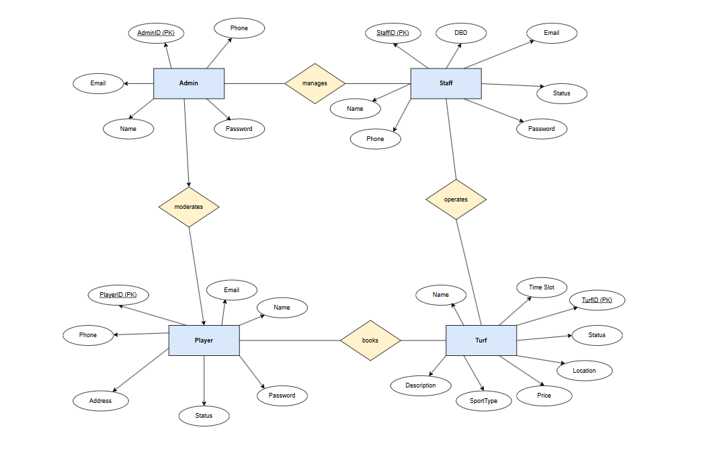

Use Case Diagram
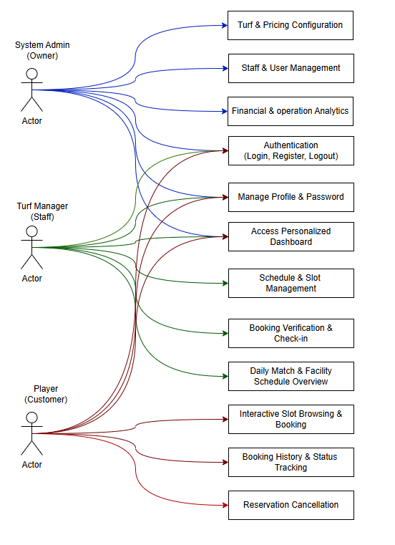

UI (Figma/Sketch)
Login Page-
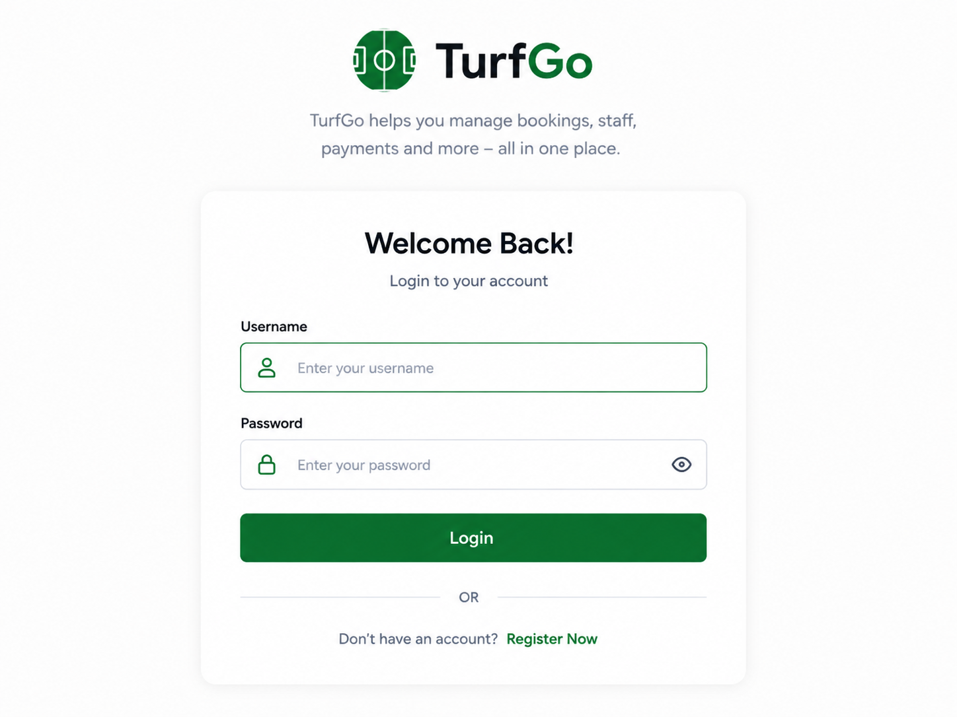

Admin-
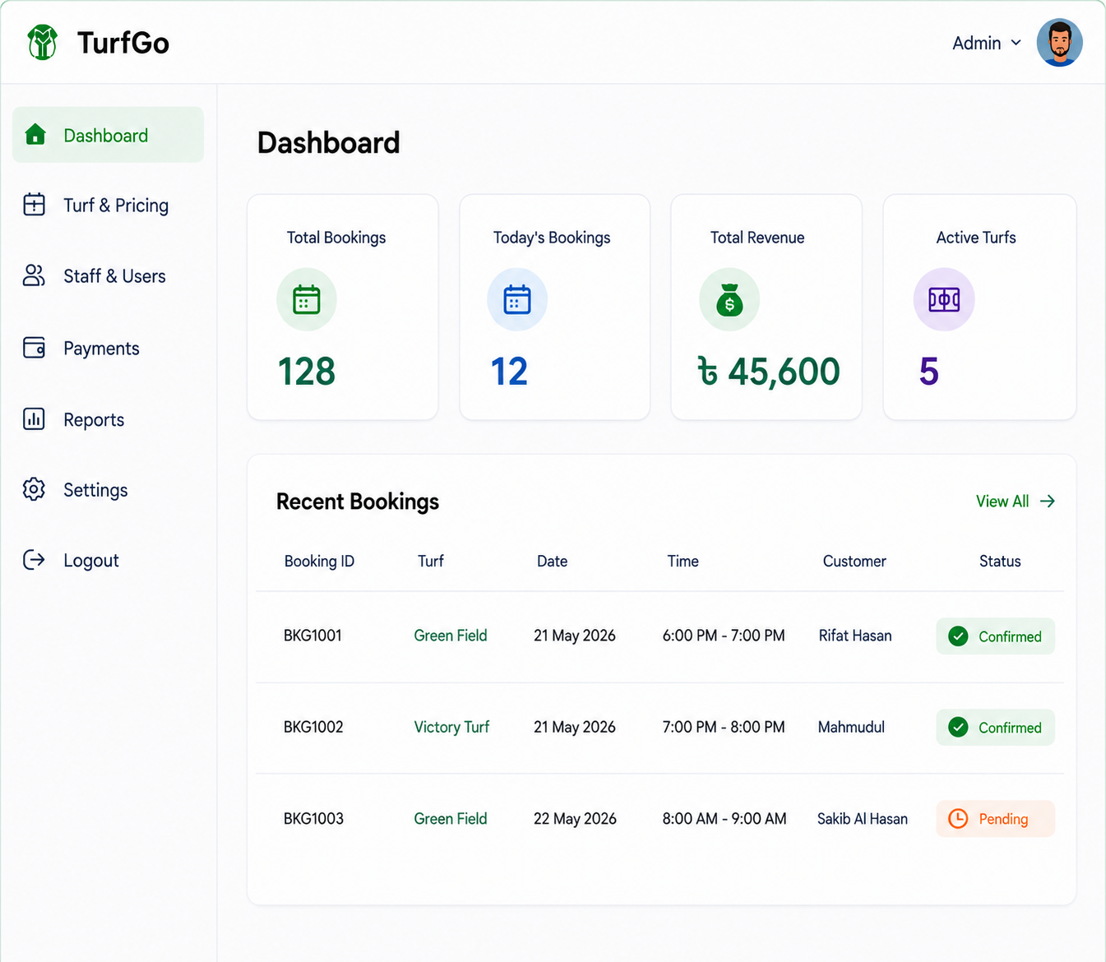

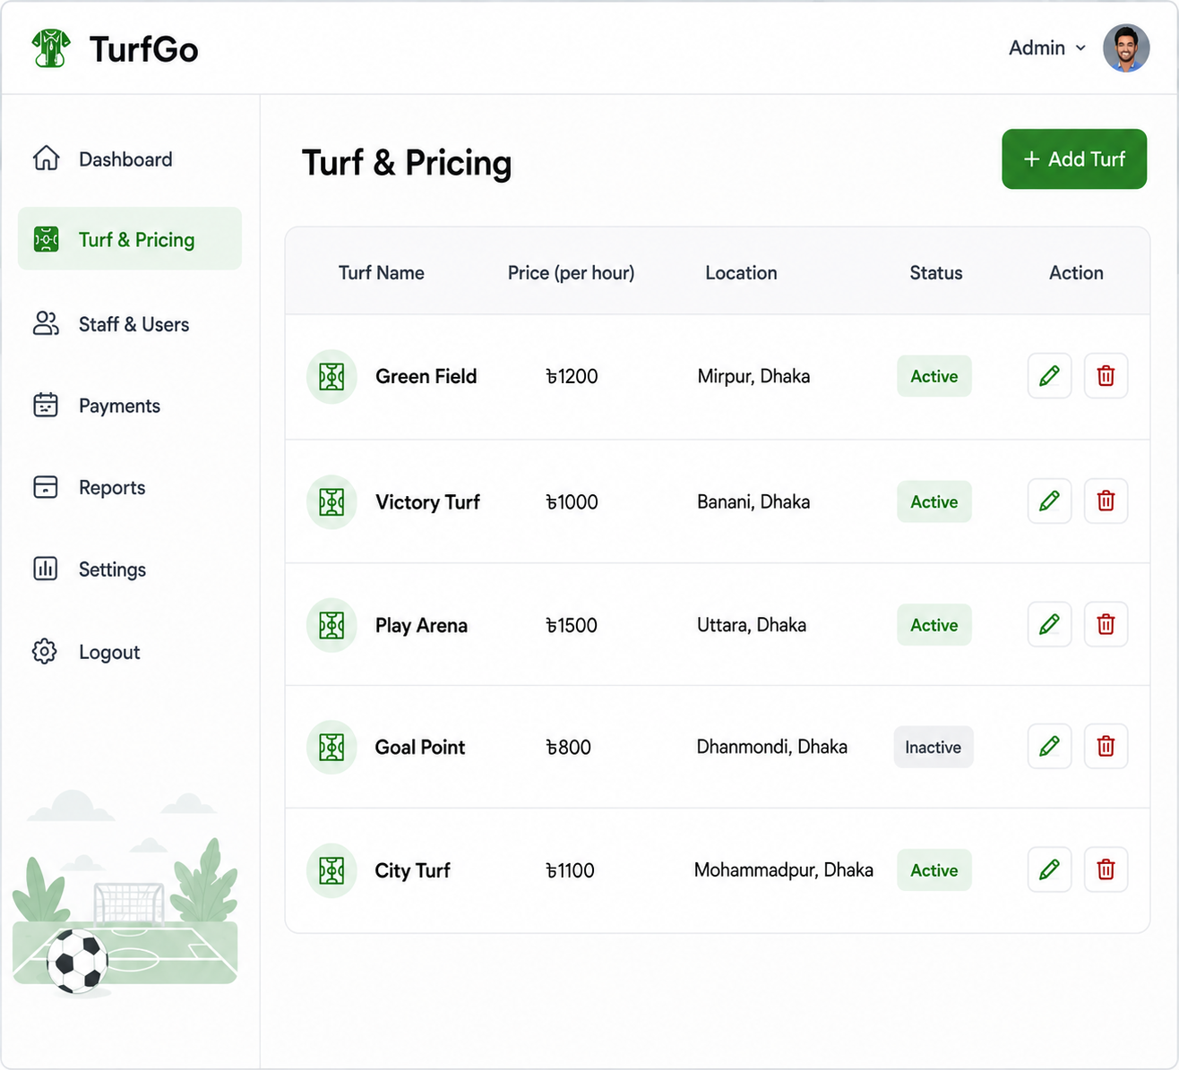

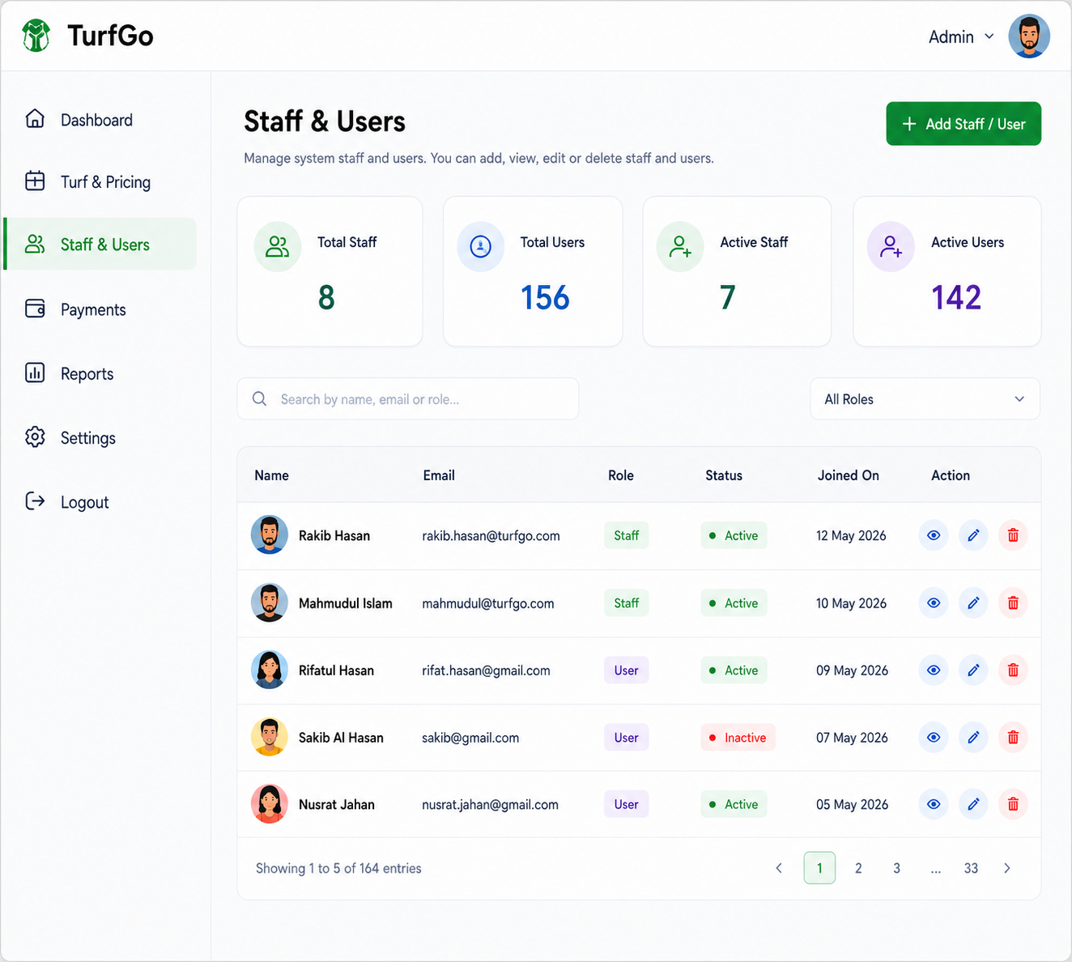

Staff-
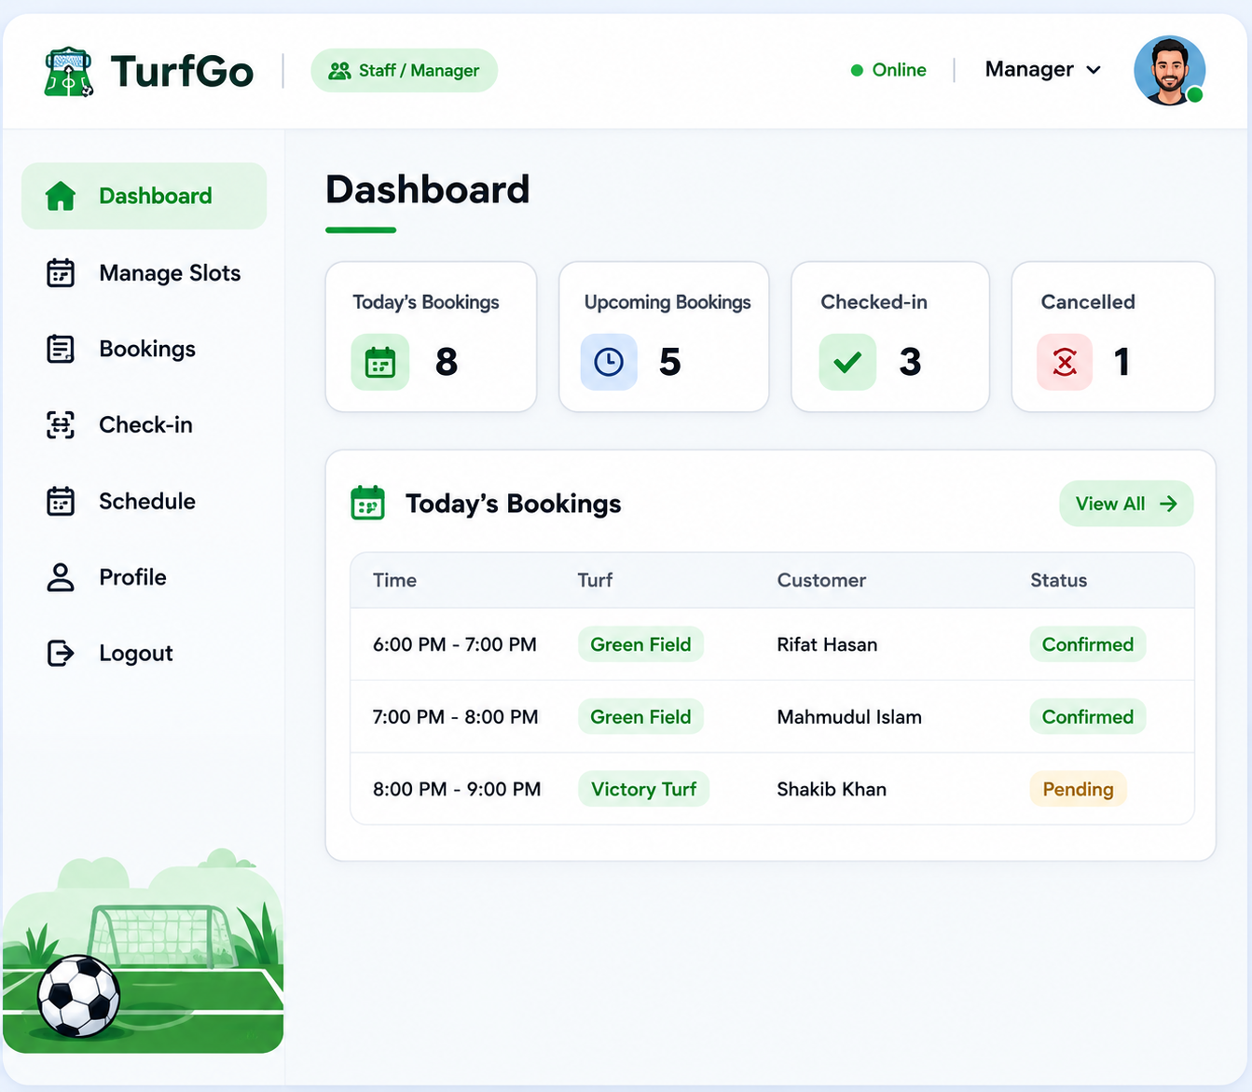

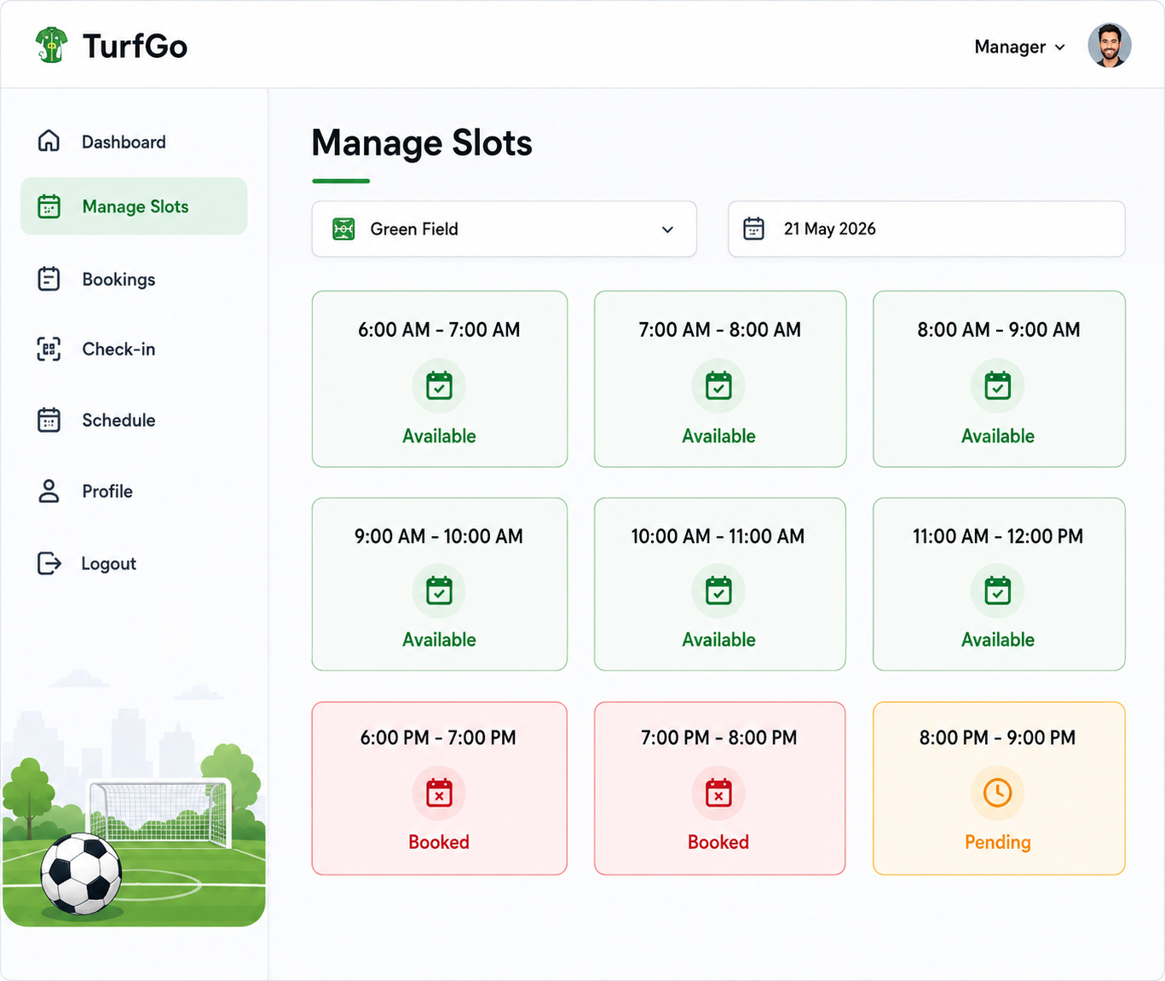
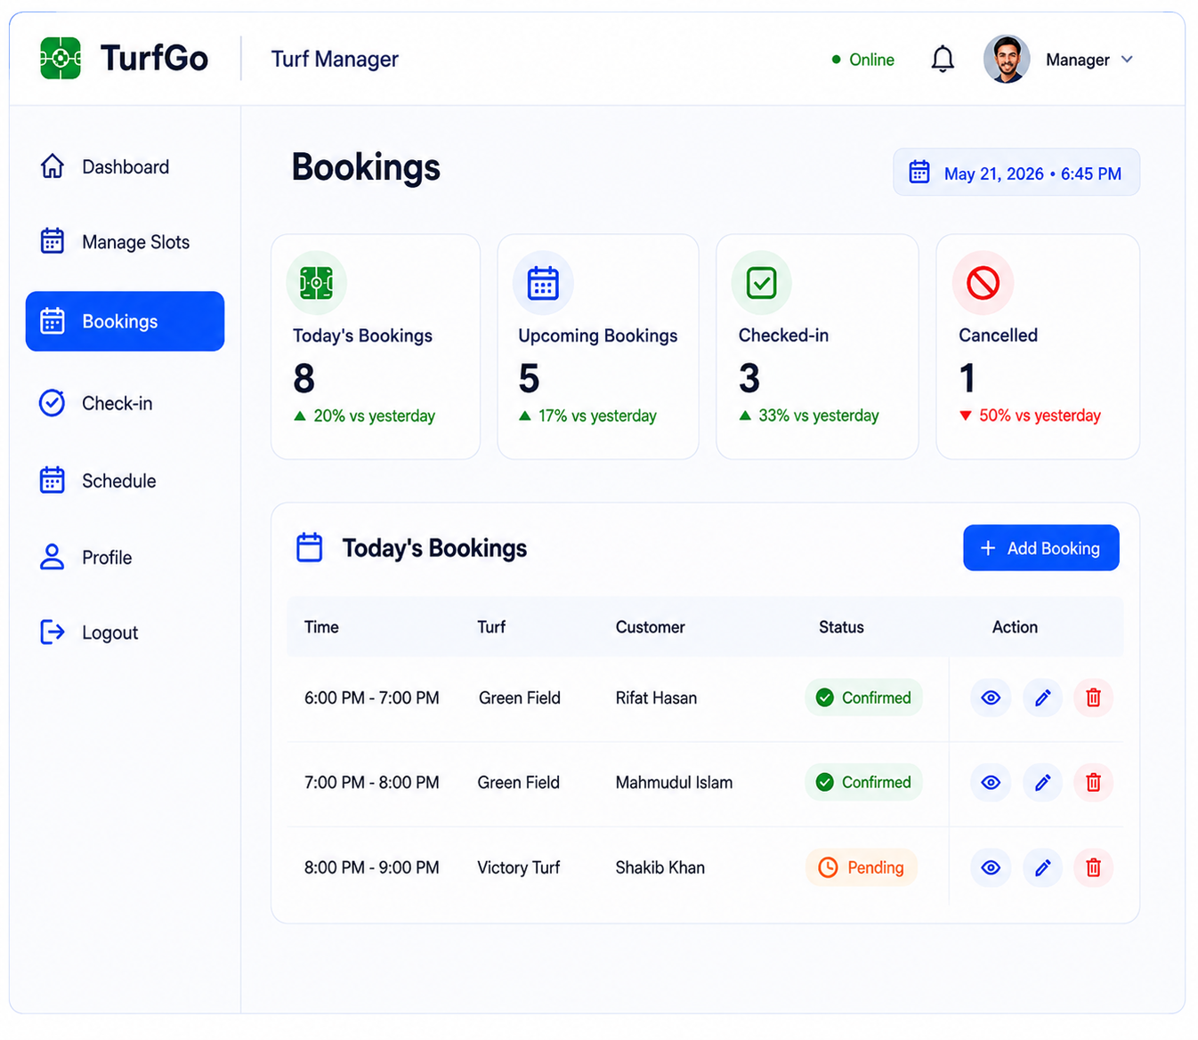

Player-
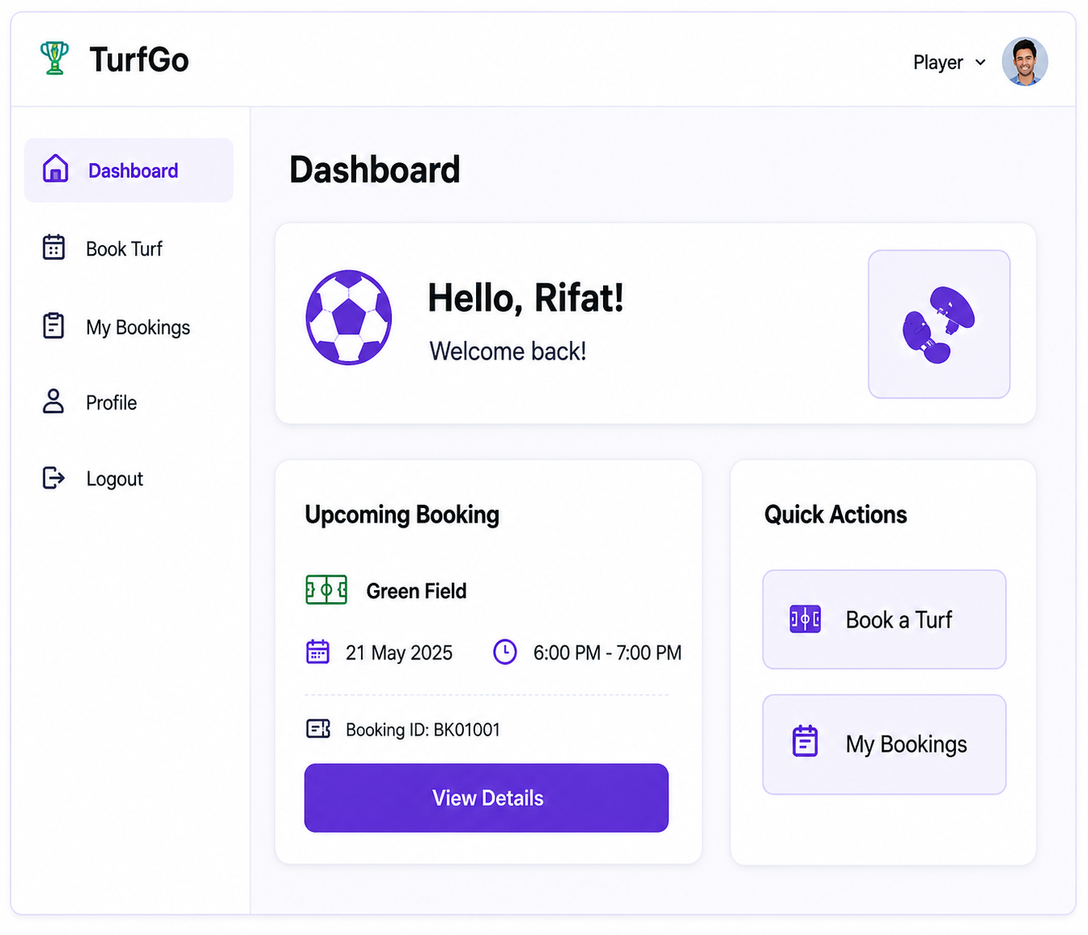

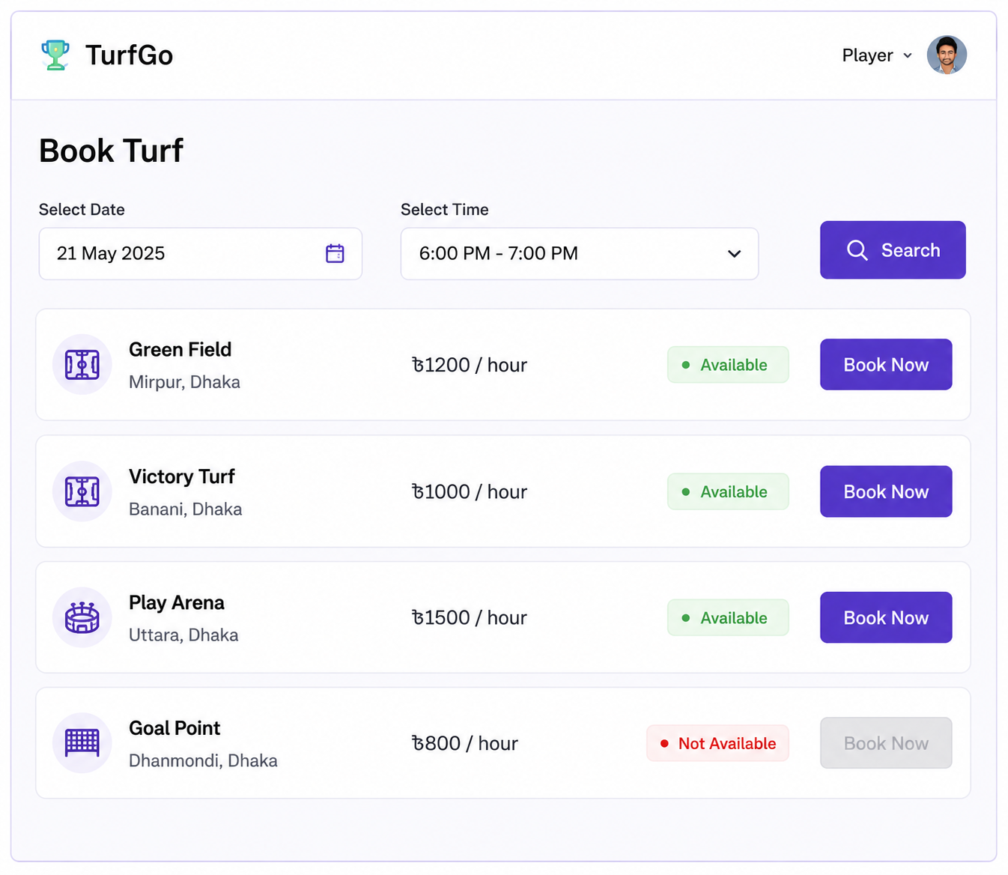

Types of Users:
1. User 1: System Admin (Owner)
2. User 2: Turf Manager (Staff)
3. User 3: Player (Customer)

- Authentication
  - Login to the system
  - Logout from the system
  - User registration
- Account Management
  - Change or reset password
  - Manage profile information (view, edit, delete)
- Dashboard
  - Access a personalized dashboard after login
Specific Features by User Type
- Features of System Admin (Owner)
1. Turf & Pricing Configuration
2. Staff & User Management
3. Financial & Operational Analytics
- Features of Turf Manager (Staff)
1. Schedule & Slot Management
2. Booking Verification & Check-in
3. Daily Match & Facility Schedule Overview
- Features of Player (Customer)
1. Interactive Slot Browsing & Booking
2. Booking History & Status Tracking
3. Reservation Cancellation

